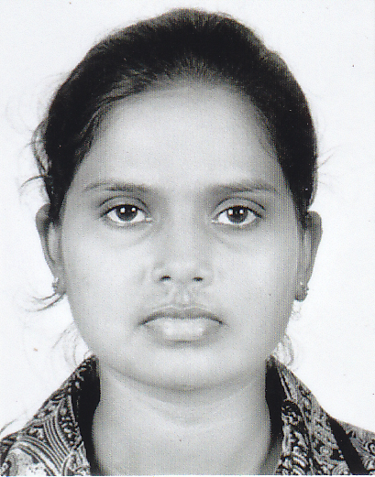 | Ms. Ilakkiya Sivalingam  45/25A,Peterson lane,  Colombo 06.  Phone: (94) 77 3917 569 E-mail- ilakkiya417@gmail.com
Career Objective
To find a gainful employment opportunity in a place, where I could further enhance my skills and experiences while employing my knowledge productively for my employer and developing my career path.

Professional and Academic Qualification
Bachelor of Business Administration (B.B.A) Specialized in Human Resource Management, University of Jaffna (2009-2013) with First class.

G.C.E. (A/L) Examination, Sri Lanka

Institution | : J/ Chavakachcheri Hindu College
Graduation | : 2007
Index No | : 6298389
 |  | Accounting |  |  | Economics  (A) |  | (C) | Business Studies  (A)
G.C.E. (O/L) Examination, Sri Lanka

Institution | : J/ Chavakachcheri Hindu College
Graduation | : 2004
Index No | : 40091074
Religion (A)  Tamil Language (A)  Mathematics (A)  Music (A) |  |  | Buss&Acc (A)  Social Studies (A)  Science & Tech (B) |  |  | Eng.Literatu (C)  Geography (A)  English Language (A)
Diploma in English
Institution | : British Business College
Graduation  Achievement | : June 2011  : Completed
Working Experience
- I have been worked as Trainee at Bank of Ceylon, Chavakachcheri Branch more than three months (2008).

Professional Qualifications
- Completed Diploma in MS office
- Completed Diploma in Accounting Package
- Proficient in Internet & E-Mail
- Part Qualification in AAT

Extra-Curricular Activities
- I have done the project “Impact of knowledge management on performance of Banking sector employees in Jaffna” under the supervision of Mrs. M.Raweeswaran, Dept. Of Human Resource Management, Faculty of Management Studiees & Commerce, University of Jaffna.
- Editor of school commerce Union 2007.

Language Proficiency
Language | Speak | Read | Write
English | Excellence | Excellence | Excellence
Tamil | Excellence | Excellence | Excellence
Sinhala | Good | weak | Good

Personal Profile
Full Name : Ilakkiya Sivalingam
Permanent Address: Allarai south, Kodikamam.
NIC Number | : 886081472 V
Nationality | : Sri Lankan
Gender | : Female
Civil Status  Date of Birth | : Single  : 17th April, 1988

Non Related Referees
Mr. S. Chandrakumaran
Manager,
Manager, Seylan Bank, Chavakachcheri.
Tel.No: (94)776771048

Prof. K. Thevarajah,
Senior Lecturer,
Faculty of Management Studies & Commerce,
University of Jaffna,
Jaffna.
E- mail: kthevarajah@yahoo.com
Tel: (94) 21 2 241 40

I declare that particulars furnished here are true and correct to the best of my knowledge

S. Ilakkiya
----------------------------
(S.Ilakkiya)
Signature

